Selenium Notes:
Locators:
- We can identify various elements on the web using locators
- Locators are addresses that identify a web element uniquely within the page
Locators:
- Id
- Name
- Linktext/PartialLinktext
- Class name
- TagName
Customized Locators: We can generate our own locators. We cannot find directly them in HTML.
- CSS Selector
  - Tag and ID
  - Tag and Class
  - Tag and attribute
  - Tag, class and attribute
- XPath
  - Absolute XPath
  - Relative XPath
How to handle the textboxes using selenium webDriver?
How to handle basic html controls in Selenium webDriver?
TextBox,link,Button,RadioButton,CheckBox,DropDown
How to handle dropdowns in Selenium WebDriver?
Navigation methods in Selenium WebDriver
How to handle alerts in a web page using selenium webdriver?
How to handle multiple windows or tabs using selenium webdriver?
How to handle frames in a web page using selenium webdriver?
How to capture screenshots of a web page using selenium webdriver?
PageLoadTimeOut in Selenium Webdriver
Default TimeOut:300sec
Exception: TimeoutException
driver.manage().timeouts().pageLoadTimeout(Duration.ofSeconds(5));
negative value: InvalidArgumentException
Implicit Wait Timeout in Selenium WebDriver
- Open the browser
- Launch the Application
- Find the elements
- Perform the actions
Explicit Wait in Selenium WebDriver
Wait Interval – 10sec
Polling frequency – 500ms
Dynamic wait
Only applicable on the WebElement where its specified
Link: How to use Explicit Wait in Selenium WebDriver | Java | Waits
How to maximize browser window in Selenium WebDriver?
How to get URL,Title, PageSource using Selenium WebDriver?
Old: Seleniumhq.org
New: Selenium.dev
How to get WebElement properties using selenium webdriver?
Selenium XPath:
- Introduction to XPath
  - XPath stands for XML path language
  - XPath is used to find the location of any element on a webpage using HTML DOM structure
  - It was defined by the World Wide Web Consortium(W3C)
  - XPath is used to navigate nodes in any XML
  - XPath uses “path like” syntax
  - 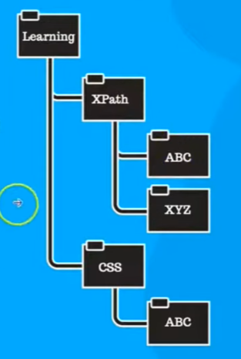
Where you can use the XPath?
Scipress,protractor,playwrite,QTP,Selnium,UFT etc
Types of XPath: Absolute XPath, Relative XPath
Absolute XPath:
Starts from the root element of the document
Relative XPath:
Starts from any point in the document based on the search criteria.
- Understand basic format?
Xpath=//tagname[@Attribute=’Value’]
Developer.salesforce.com/signup
- XPath using Attributes
//tagname[@attribute=’value’]
- XPath operators
=,!=,<,<=,>,>=
- XPath Conditions
and, or & not
- XPath with Index

- XPath functions
Text,Contains, Starts-with,Normalize-space,Last,position
//a[contains(text(),’account’)]
//div[contains(@class,'signin')]
- XPath Axes
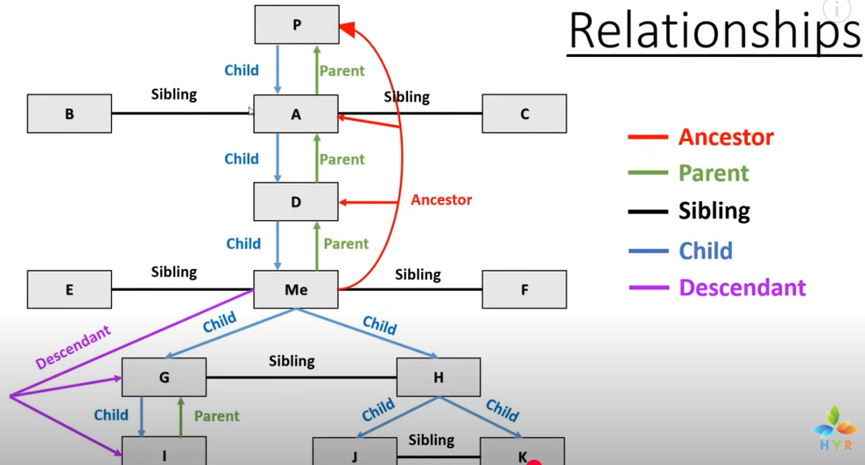
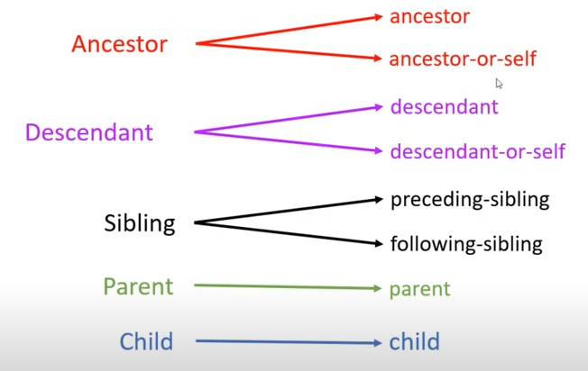

- XPath Shortcuts
text() - .
- Third Party XPath tools
Chropath, SelectorsHub, LetXPath
- Common mistakes

Perform Mouse Actions in Selenium WebDriver:
- Double click
- Right clik
https://demo.guru99.com/test/simple_context_menu.html
- Mouse Hover

- Drag and Drop
JavaScriptExecutor in Selenium WebDriver:
- What is JavaScriptExecutor?
  - It is an interface used to execute the javascript on a webpage provided by selenium.
  - It contains two methods: executescript and executeAsyncScript
- How to find elements in a webpage using JavaScriptExecutor?
- How to enter text into a textbox using JavaScriptExecutor?
- How to perform click operation using JavaScriptExecutor?
- How to highlight web elements using JavaScriptExecutor?
- How to perform scroll operations using JavaScriptExecutor?

Id: document.getElementById(‘email’);
Name: getElementsByName(‘email’)[0];
Classname: getElementsByClassName(‘inputtext’)[0];
Tagname: document.getElementsByTagName(‘input’)[2];

css selector: document.querySelector(‘#email’);
xpath:document.evaluate(xpathexpression,contextNode,namespaceResolver,resultType,result).singleNodeValue;
document.evaluate(“//input[@id=’email’]”,document,XPathResult.FIRST_ORDERED_NODE_TYPE,null).singleNodeValue;
document.getElementById('subscriber-email').value='JAVA';

